**VPM's K.G. Joshi College of Arts and N.G. Bedekar College of Commerce (Autonomous), Thane**

**Activity Report**

**1. Title of the activity** – महाकवीकालिदासदिनोत्सव

**2. Name of the Departments** - Department of Sanskrit

**3. Day and Date** - 6th July 2024

**4. Name of Resource Person** -

**5. No. of students benefited** - Male -3 Female-08 Total-11

**6. Purpose of the Activity:**  Honoring a Literary Genius - Mahakavi Kalidas is regarded as one of the greatest Sanskrit poets and dramatists in Indian history. Celebrating his contributions helps students appreciate the richness of Indian literature and heritage.

1. **Promoting Classical Language and Literature** Events on this day can spark interest in Sanskrit, classical poetry, and drama, encouraging students to explore ancient texts and the depth of Indian literary tradition.
2. **Cultural Awareness and Identity** Observing such days reinforces cultural identity and pride, helping students connect with India's glorious past in literature, philosophy, and aesthetics.
3. **Encouraging Creativity and Expression** Through recitations, dramatizations, or essay competitions, students get a platform to express themselves creatively while engaging with classical content.
4. **Inspiration from a Timeless Figure** Kalidas’s life and work symbolize wisdom, intellect, and poetic excellence. His journey from simplicity to brilliance can be deeply motivational for students.

**7. Gist of Actvity :-** Celebrating Mahakavi Kalidas Day in college is an initiative to honor the legacy of one of India’s greatest classical poets and dramatists. The day serves to promote appreciation for Sanskrit literature, encourage cultural awareness, and inspire students through Kalidas’s timeless works. Through literary events, dramatizations, poetry recitations, and discussions, students gain insight into India’s rich literary heritage and the intellectual brilliance of Kalidas.

This celebration fosters creativity, literary engagement, and cultural pride, while also strengthening students’ connection to the country’s artistic and philosophical traditions.

**8.  Teacher Incharge** :- Asst. Prof. Swati Bhalerao/ Asst. Prof. Shreya Moghe

Thanks and Regards

**Asst. Prof. Swati M. Bhalerao  Dr. Suchitra A. Naik**

**HoD Sanskrit Principal**

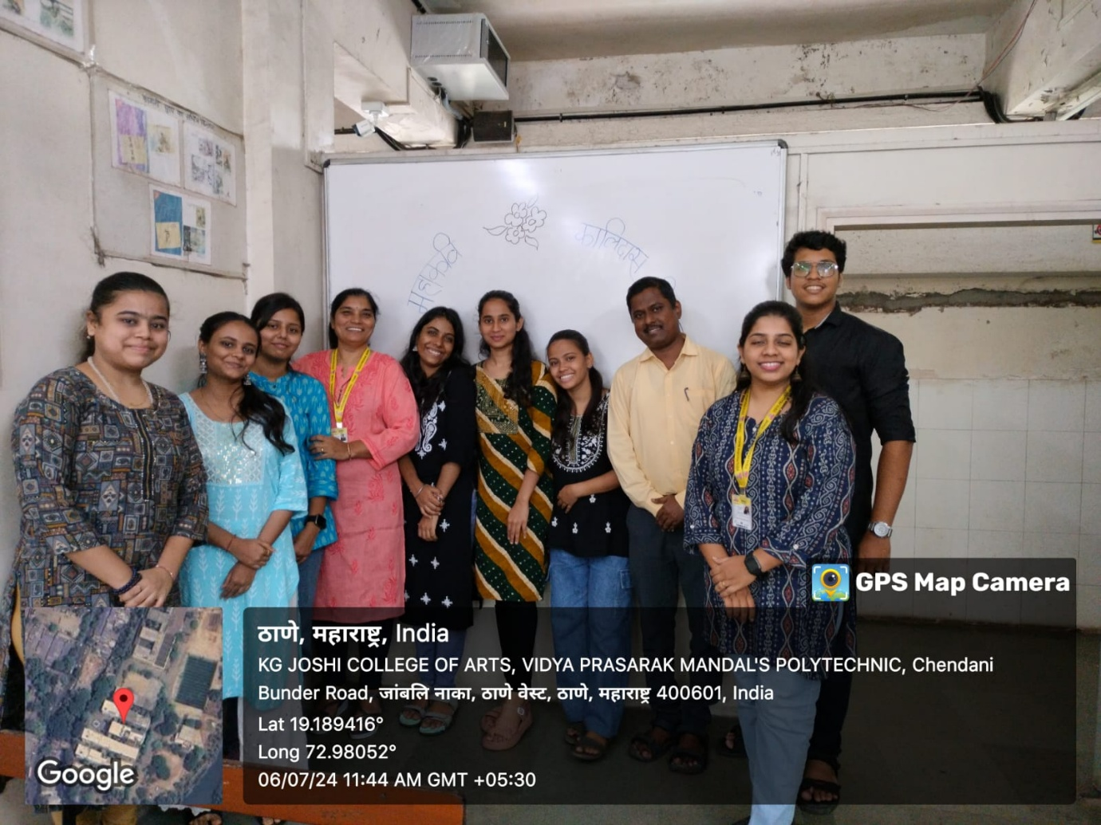

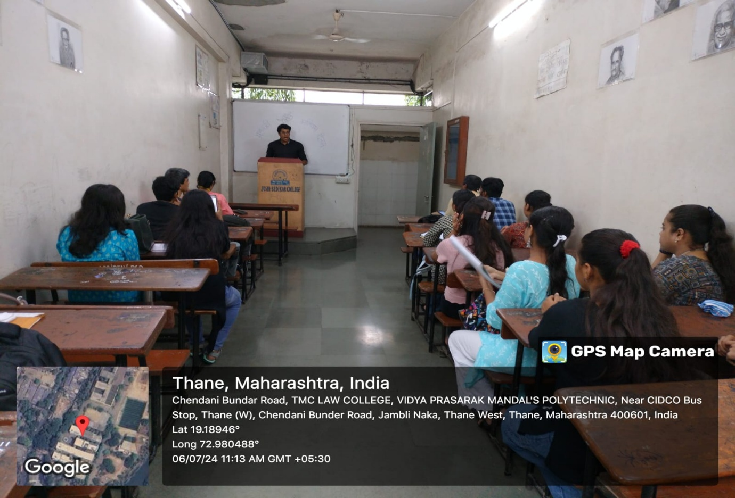MAHAKAVI KALIDAS DAY 6/7/2024